Project Document Description

**Code folder:**

GLWY_Julia.ipnyb

Data wrangling for Covid-19 and unemployment topic and data visualization using Julia

GLWY_R.ipnyb

Data wrangling for Covid-19 and Education topic and data visualization using R

GLWY_R_2.ipnyb

Data wrangling for Coivd-19 and Economic topic and data visualization using R

**Data Source folder:**

The raw data files download from three different websites.

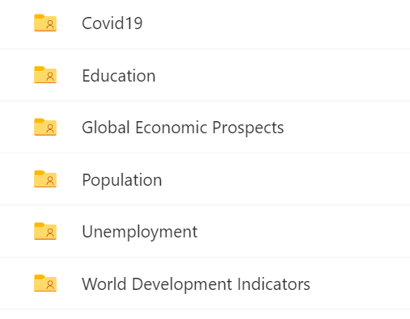

**Presentation slides:**

Presentation.pptx

**Data Visualizations folder:**

It includes all output data visualization plots.

**Output Data**

Covid_pop_edu.csv



GDP_History_2010_2021_by_country.csv



RealGDP_by_areas.csv

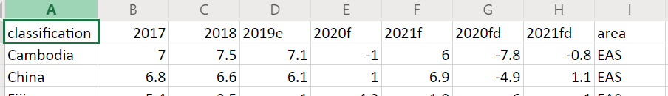

Summary_by_areas.csv

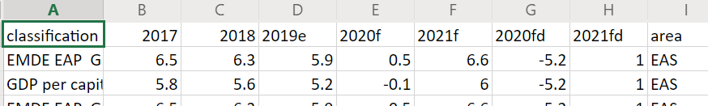

Unemployment.csv



Year_Quarterly_GDP_by_country.csv

